TD1 (federal) and TD1ON (provincial), Personal Tax Credits Return, are forms used to determine the amount of tax to be deducted from employment income. All new employees must fill out these two forms.

You do not have to complete new TD1 forms every year unless there is a change to federal or provincial personal tax credit amounts. These changes could include, but are not limited to, the following situations:
- You are no longer paying tuition that you have previously claimed
- You are now receiving pension income that you would like to claim
- You now have a spouse or eligible dependant that you are supporting
- You want to increase the amount of tax being deducted from your bi-weekly pay

If you would like to update your tax credit amounts, please fill out the forms attached and send them back to Payroll at payroll@trentu.ca

How do I complete the TD1 form? Follow the below steps:

- Fill out your personal information at the top of each of the forms
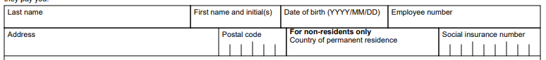

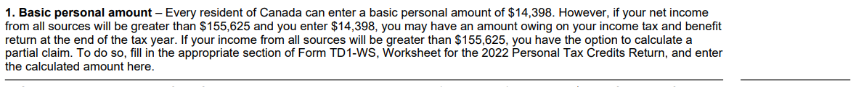
- Enter the applicable amounts on the corresponding lines (1 to 12). If you are unsure what amounts you should claim, you should speak to a tax professional to advise based on your personal circumstances.

- Add up all the amounts claimed and enter the total on line 13:

- Determine whether any other information on page 2 of the form is applicable to you. For example, if you have already claimed personal tax credit amounts with another employer, you may not claim them again.

- If you know that your total income for the year will be less than your total claim amounts on the TD1 form, you can check the box on page 2 of the form, and your employer will not deduct tax from your earnings.

- Based on advice from a tax professional, you may want to request additional tax to be deducted (only available on TD1)

Sign and date the form at the bottom of page 2:

